1. Jenkins Home page after successful installation

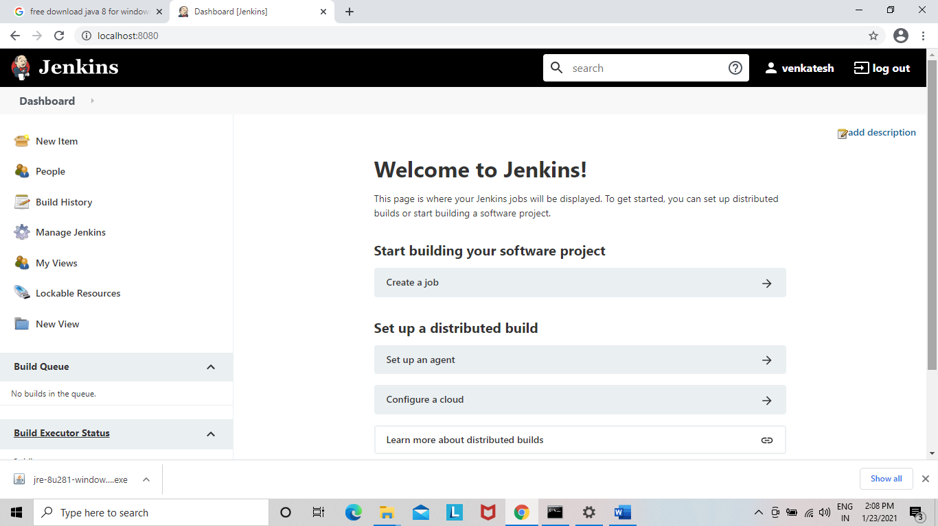

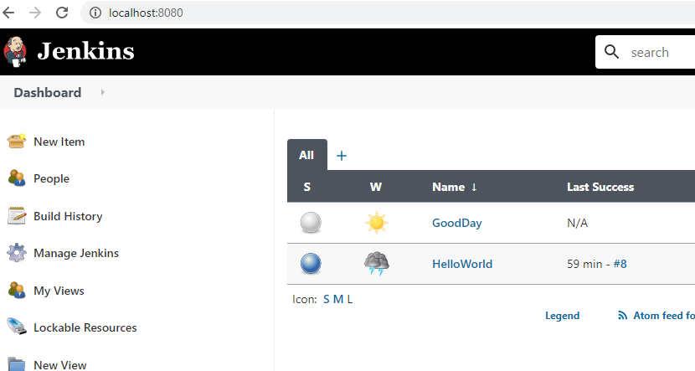

1. Creating the HelloWorld Java program in Github.

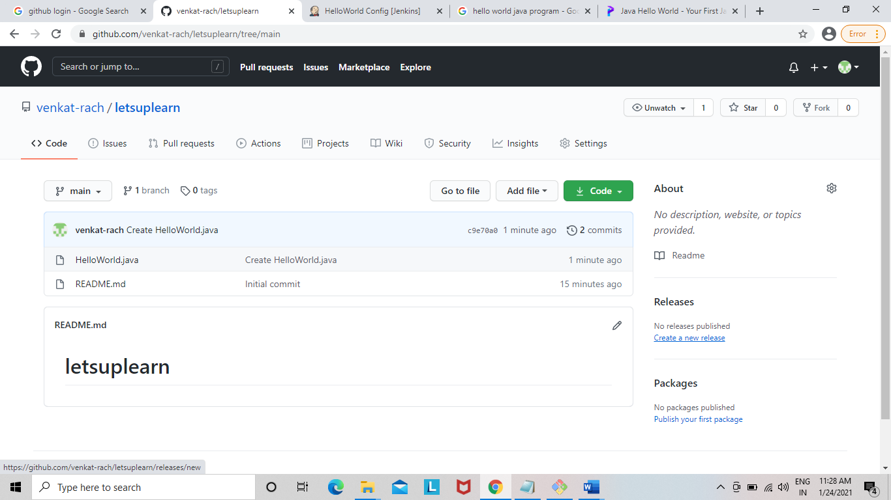

1. Configuring the Github code link in Jenkins.

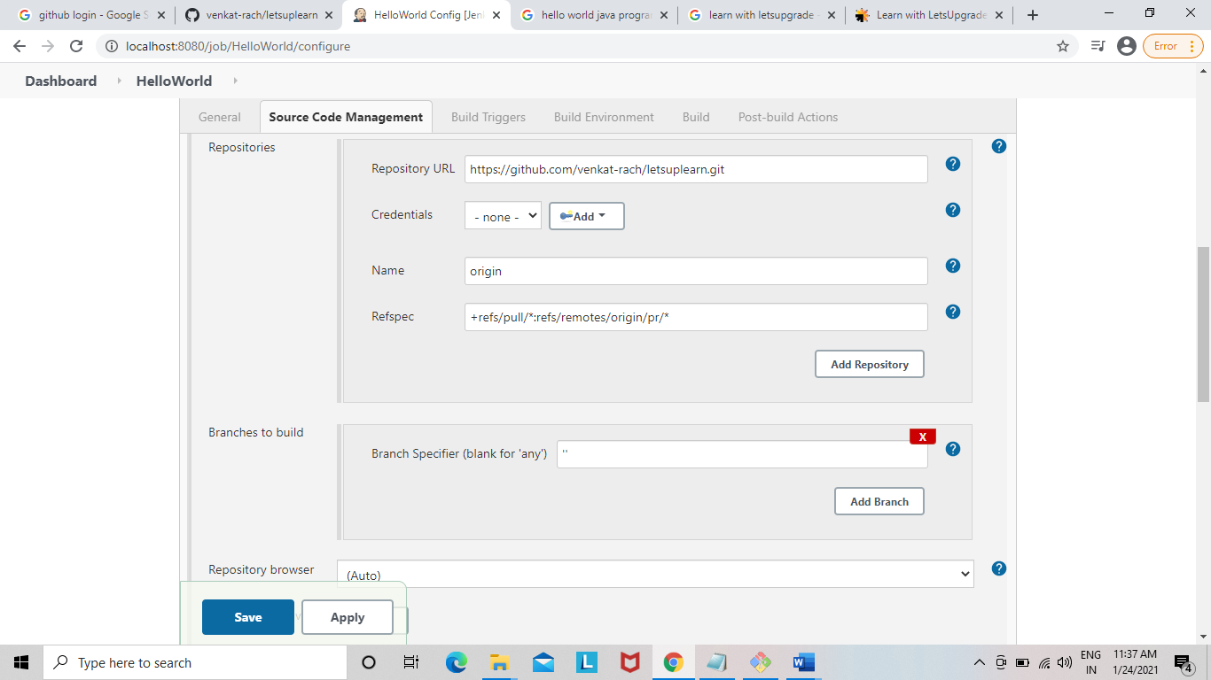

1. In Jenkins build environment providing the java executable commands.

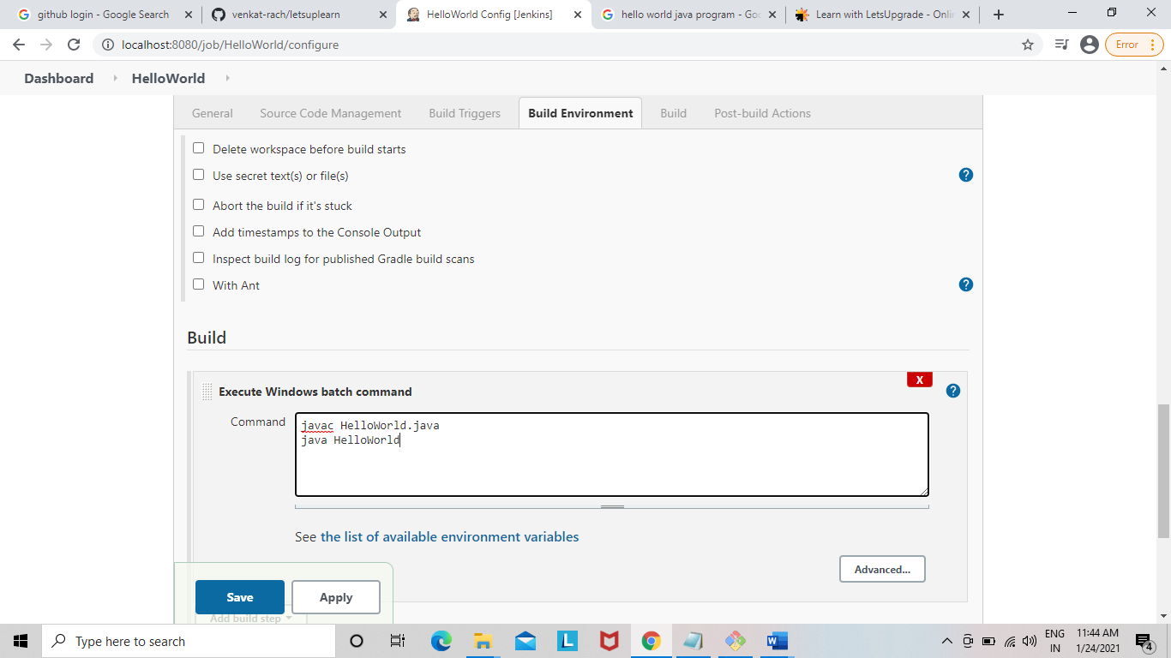

5.After debugging and changing the java path and Git path in environment variables as well as in Jenkins Global tools configuration got the success message.

